# Accessing MyLab Math in D2L

1. Enter your D2L Course.
2. Click on Content tab at the top left of the D2L page.

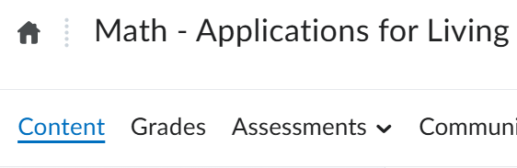

1. Then click on the “MyLab” content tab on the left side of the screen. Then click on Course Materials in the middle of the screen.

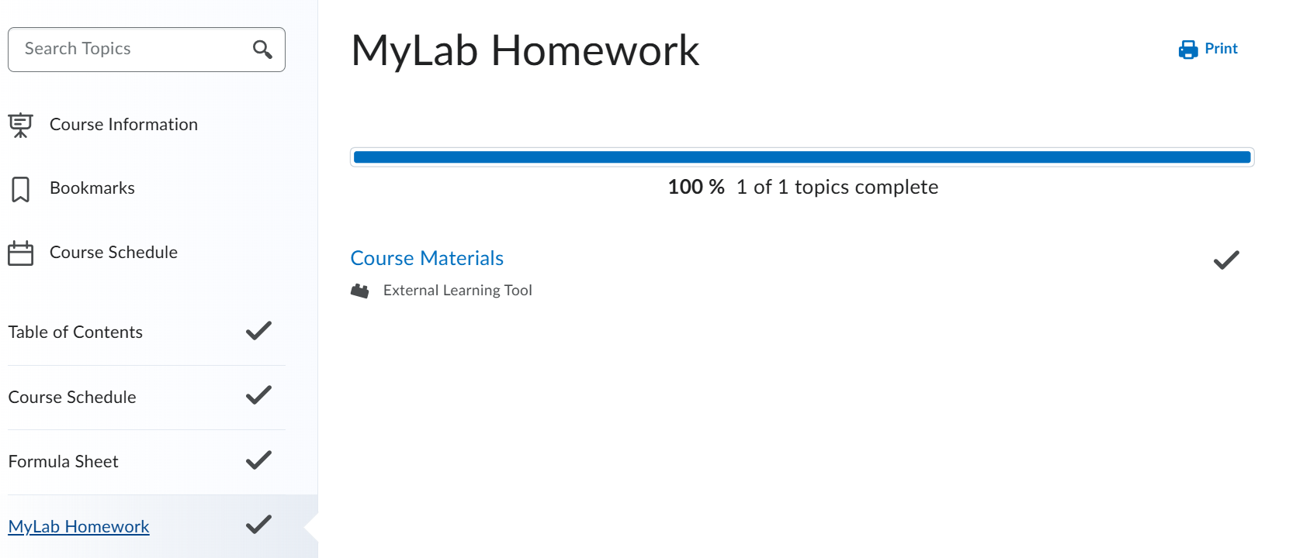

1. Your Pearson Materials tied to this course will appear. You should have a “Launch Courseware” button for MyLab Math.

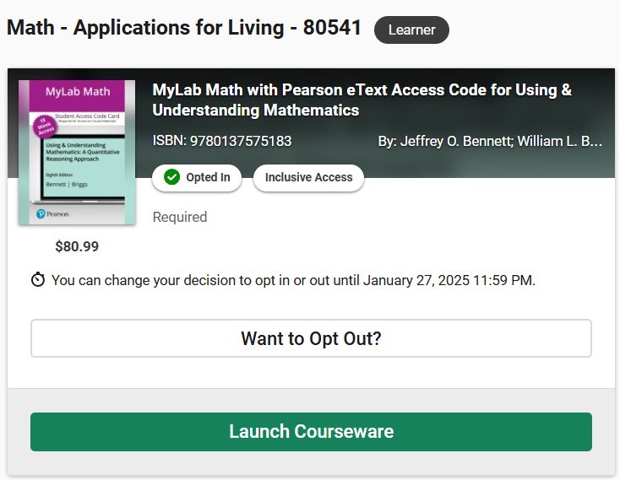

1. Click “Launch Courseware” to access the online homework and an electronic version of your textbook. You will be prompted to create a Pearson account in MyLab (see instructions below). Make sure to use an email that you will check regularly when registering as any “Ask My Instructor” replies will be sent to whatever email you register with.

# Creating a Pearson Account

1. If prompted, read and select “I Accept” to agree to Pearson’s End User License Agreement.
2. Link your D2L account to either:
   1. An existing Pearson account by entering your Pearson username and password.
   2. A new user Pearson account by selecting Create Account. **Please use name listed on D2L, nicknames can be confusing when transferring over grades.**

Picture to Sign into Pearson

1. After linking your accounts, select GO TO MY COURSES.

# Opt Out Instructions

If you want to opt-out of access, click the “Want to Opt Out?” button on D2L. Students can opt out if they choose but must do so by September 4th, 2025. Students who opt out will have their account credited for the cost of the book but will no longer have access to the materials.

**OPTING OUT WILL COST YOU MORE MONEY!**

**Students must be registered in MyLab Math by the opt-out date or they will automatically be opted out and not have access to the MyLab Math shell.**